Reflection(week 8):-

In week 8 lab, Firstly we installed mongodb by typing npm install MongoDB - -save and mongoose by npm install mongoose - -save. After doing this, we connect MongoDB by using URL= localhost: port number/database name MongoDB port is 27017. With this thing done then we started coding in the index.js file. The code was given in the lab tutorial as a guide also I have performed all the tasks given and mentioned below which are from tasks 1 to 7 and all of this lab codes are in my GitHub link which is at the top of this portfolio pdf.



The purpose of doc1.save and .then in the code is to ensur that database connection or any operations is successfully completed before excuting. Also helps to controls errors as well.

Task 1:- connect with mongoDB and add a single document

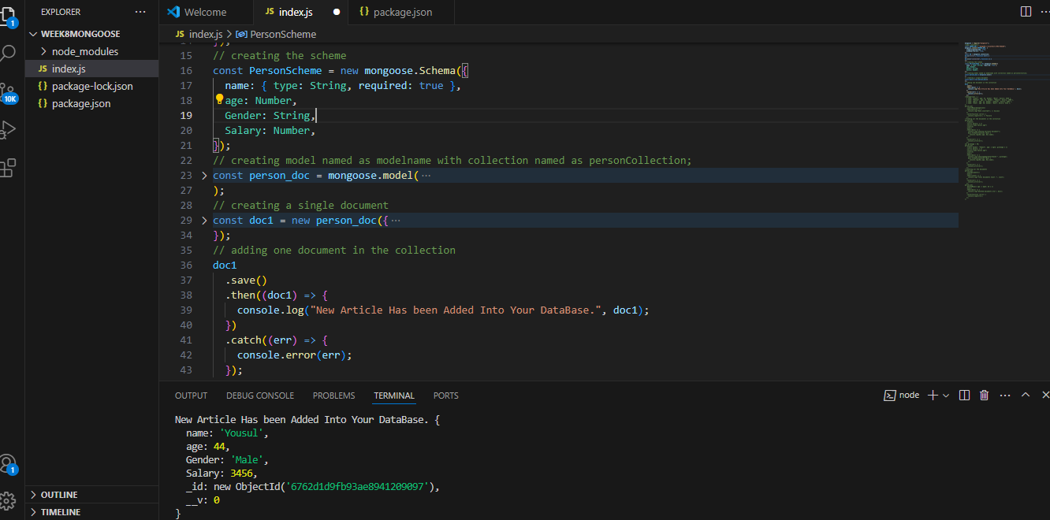

Task 2:- Adding multiple documents

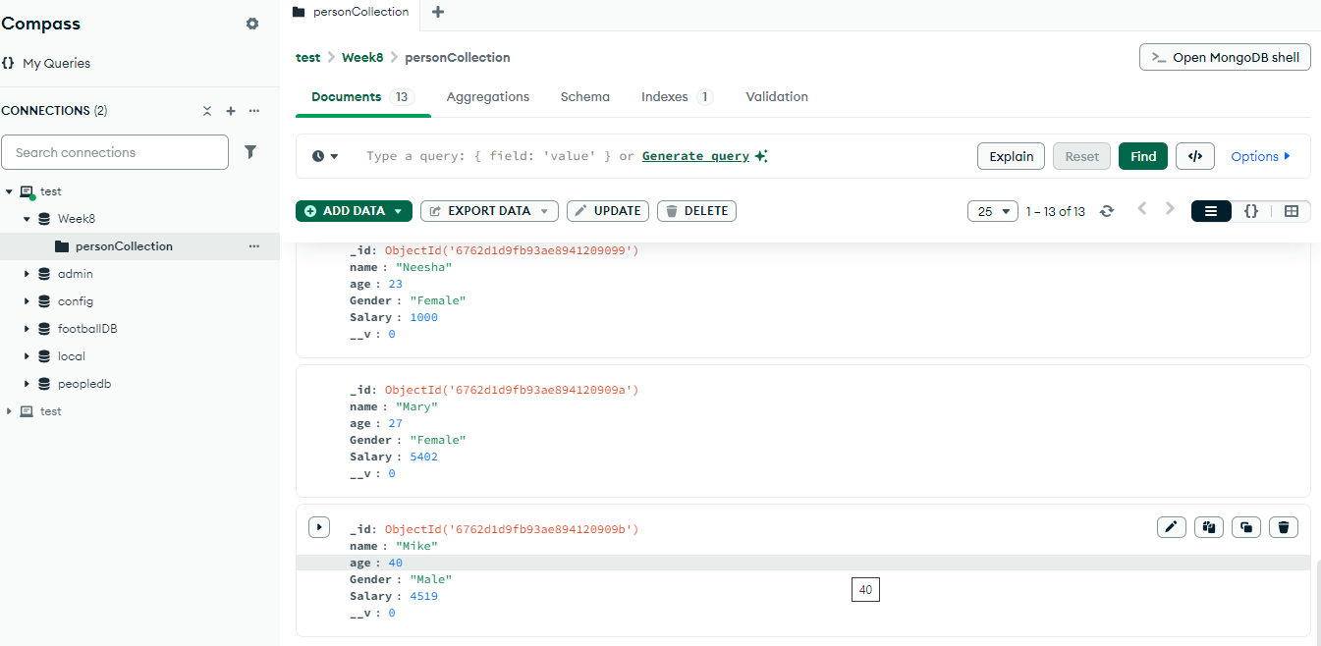

Task 3:- fetching the data use of find:

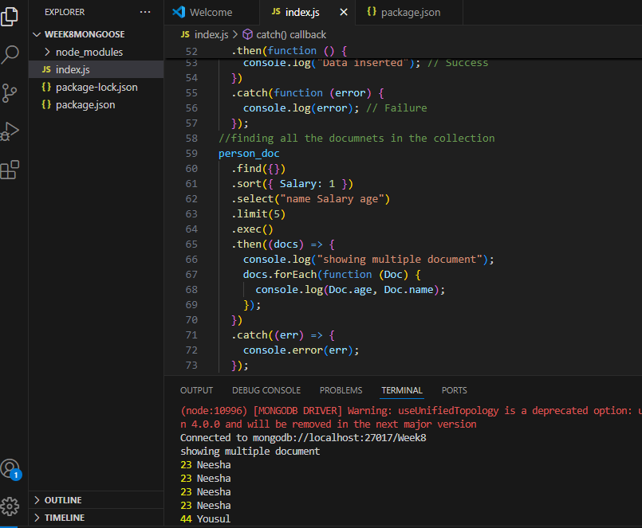

Task 4:- find command with filtering criteria. Run the find command s for which gender =Female and age is greater than some given number

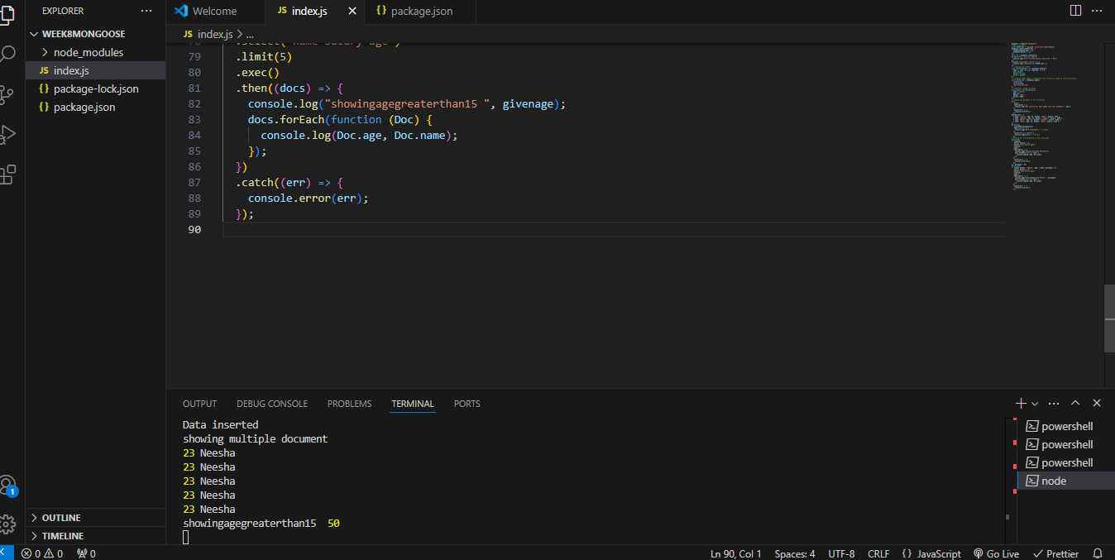

Task 5:- : write a query to return the total number of documents in the collection.

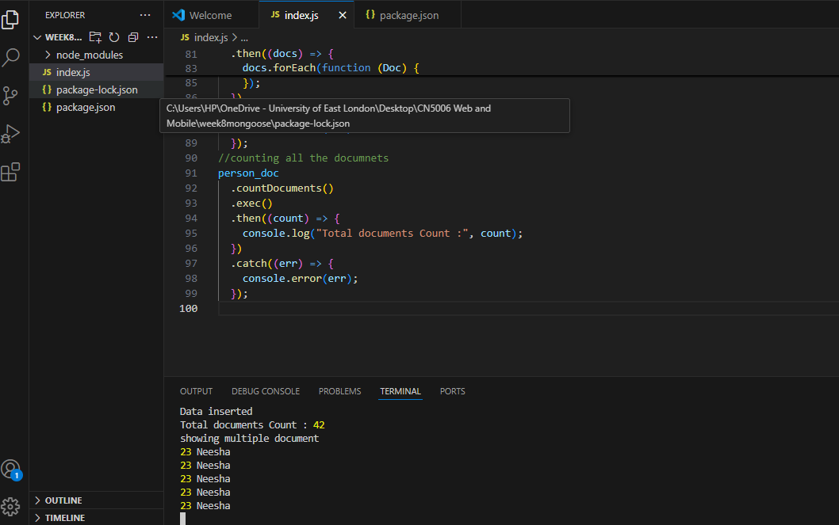

Task 6:- Delete the documents for a given criteria

For this we will use deleteMany and the filtering criteria is to delete all records for which age is greater than 25.

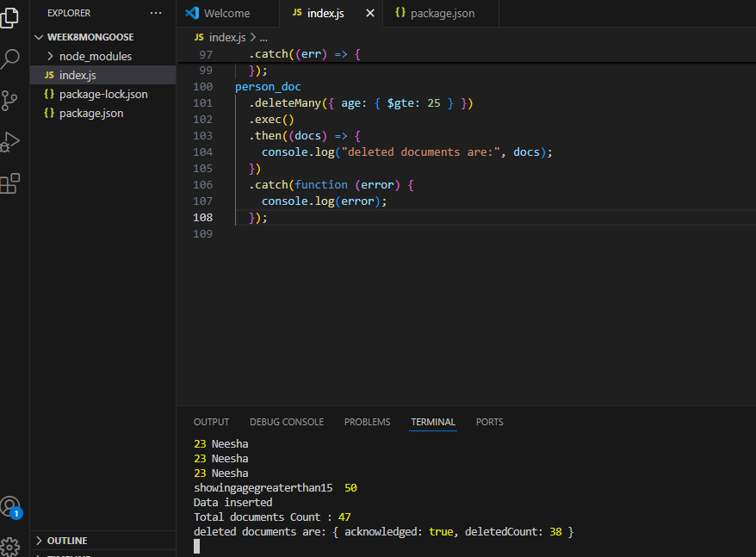

Task 7:- Update all document of which the gender is female and set their salary to 5555 code in index.js

